Types of Pronouns
# Source: AI Source: Provided by: [Data Path: Persons Table -> ID Column: 1, Name_En Column: Motasem Essam] -> From: [Chatgpt (GPT-4-turbo)] on [7/27/2025]
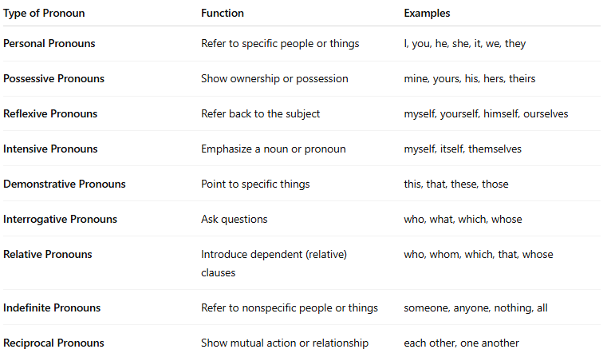

Type of Pronoun | Function | Examples
Personal Pronouns | Refer to specific people or things | I, you, he, she, it, we, they
Possessive Pronouns | Show ownership or possession | mine, yours, his, hers, theirs
Reflexive Pronouns | Refer back to the subject | myself, yourself, himself, ourselves
Intensive Pronouns | Emphasize a noun or pronoun | myself, itself, themselves
Demonstrative Pronouns | Point to specific things | this, that, these, those
Interrogative Pronouns | Ask questions | who, what, which, whose
Relative Pronouns | Introduce dependent (relative) clauses | who, whom, which, that, whose
Indefinite Pronouns | Refer to nonspecific people or things | someone, anyone, nothing, all
Reciprocal Pronouns | Show mutual action or relationship | each other, one another

